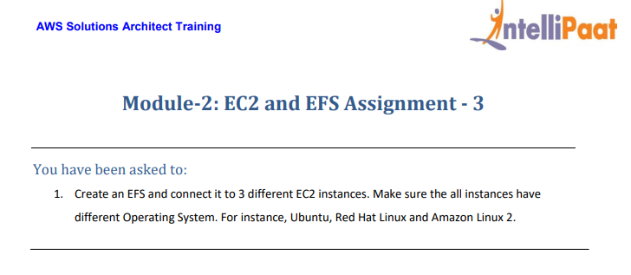

Solution

1. Create three EC2 instances with different OS

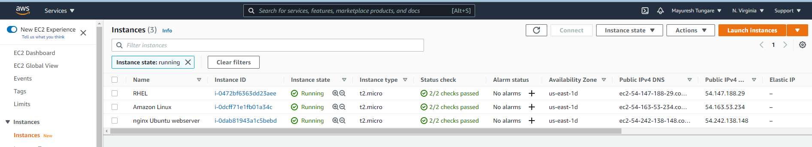

1. Go to Services Dashboard and choose EFS option 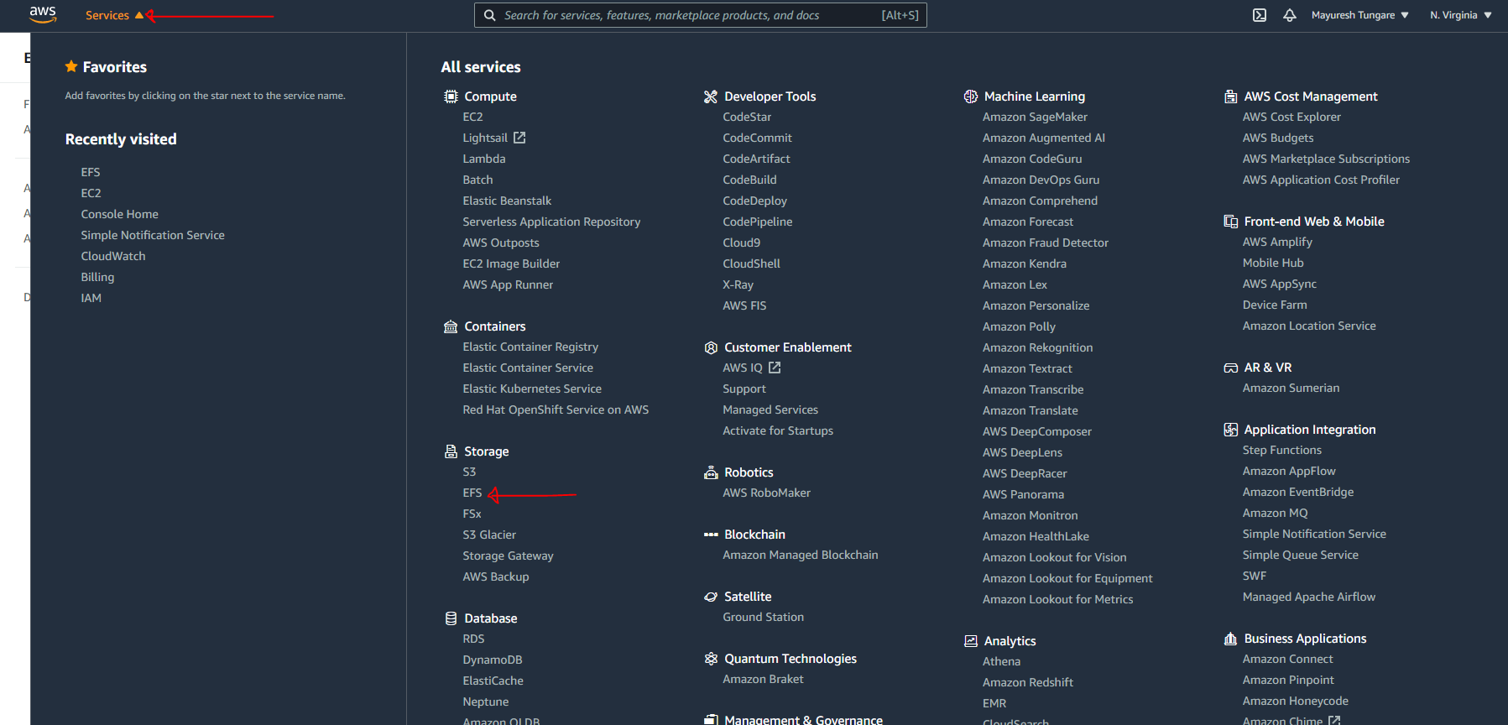
2. On EFS dashboard, click on Create file system.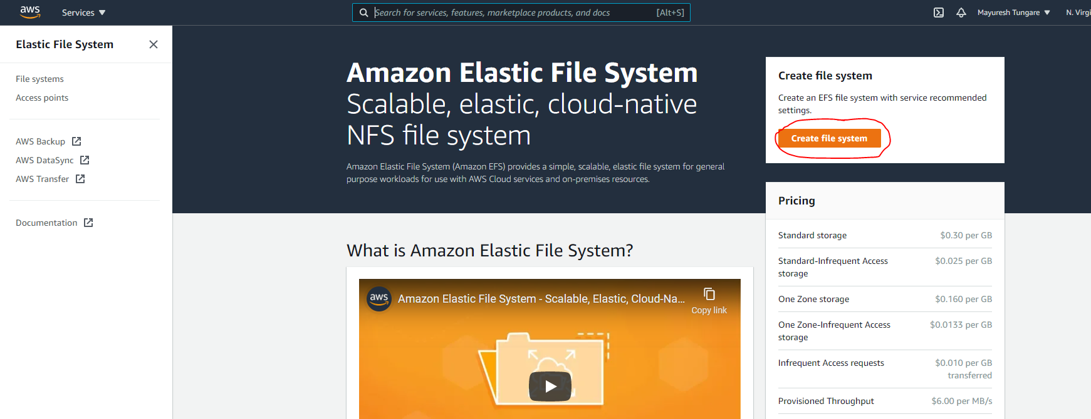
3. Fill out the details as below and choose the correct Availability Zone and then click on Create.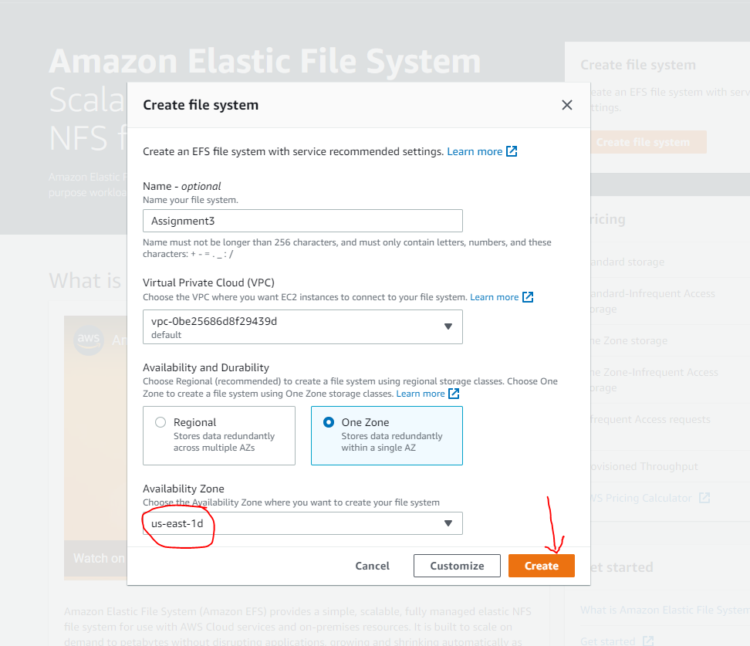
4. You will see a message (as below) that confirms creation of EFS. 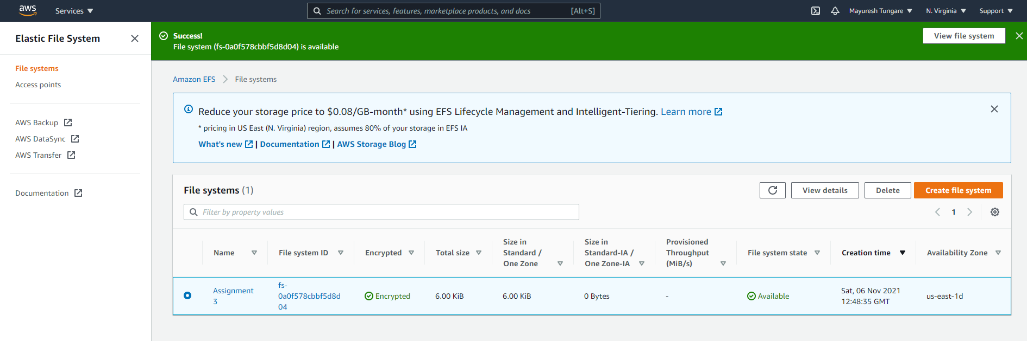
5. Now log onto your first server (Ubuntu OS) and create a mountpoint as below

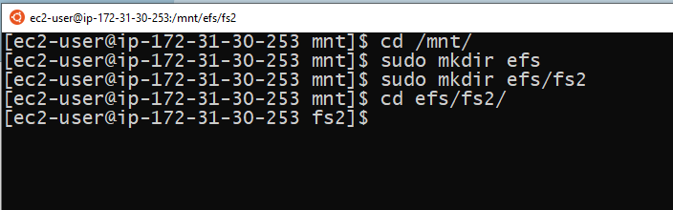

1. EFS is now mounted on first EC2 (Ubuntu OS) instance

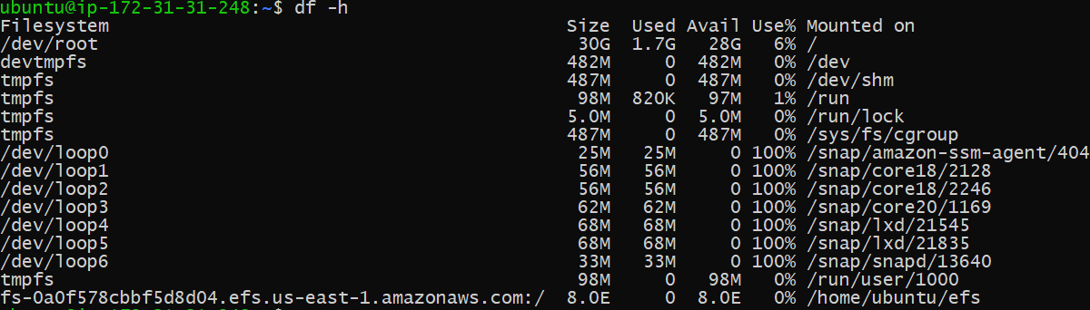

1. Similarly, EFS is now mounted on second EC2 (Amazon Linux OS) instance

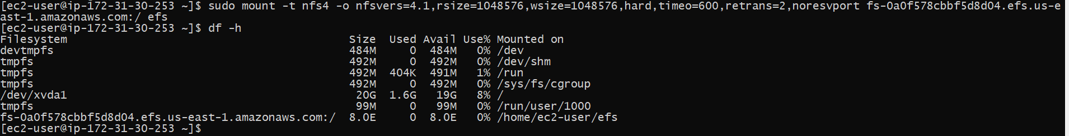

1. Similarly, EFS is now mounted on third EC2 (Redhat OS) instance

